

|  |  |
| --- | --- |
| **Proposal By** | **Proposal To** |
|  |  |
| |  | | --- | | **Name:** Gokul Ajith | | **Name:** Jois Ramesh |
| **Designation:** Project Manager | **Designation:** |
| |  | | --- | | **Telephone:** | | **Telephone:** |
| |  | | --- | | **Mobile:** 7722084700 | | **Mobile:** |
| |  | | --- | | **E-Mail: Ajith.gokul@in.bosch.com** | | **E-Mail:** Ramesh.Jois@in.bosch.com |
| **Proposal Submitted on: 29th July 2024** | |

**PROPOSAL DETAILS**

|  |  |
| --- | --- |
| Confidentiality: | Confidential |
| Copyright and reproduction: | Not allowed without the written consent from Bosch Global Software Technologies Ltd |
| Validity: | 90 days |
| Reference Number: | BD/WPA-CSS1_SX/EDS3-MM |

Proposal to:

BD/WPA-CSS1

Project for:

AI Powered SMT Support Tickets Analyzer

Contents

1. Project Background 3

2. Project scope 5

2.1. Scope 5

2.1.1 Overall, Scope 5

2.2 Out of Scope: 7

2.3 Architecture 8

2.4 Pre-Requisites: 8

2.5 Bill of Materials (BOM)/ Licenses 10

2.6 Assumptions: 10

2.7 Deliverables, Receivables and Acceptance Criteria 11

3. Project schedule 13

4. Project Management 14

4.1 Change Request Procedure: 14

4.2 Project Execution 15

4.3 Escalation Management 16

4.4 Communication Plan 17

4.5 Risks & Mitigations 17

4.6 Information Security 18

5 Commercials 19

5.1 Price Summary 19

5.2 Payment Milestones 19

5.3 Commercial Terms and Conditions 19

6 Signatures 21

# Project scope

## Scope

Below the scope to build application to review and analyze support tickets.

**Environment Setup:**

Design, development, and deployment of support ticket analysis on-prem with 2 environments:

1. Development (Dev)
2. Production (Prod)

**Scope for Support Ticket Analysis:**

1. Design, develop and deploy applications to review and analyze support tickets (submitted by users through SMT).
2. This application will be using an NLP based solution to identify and categorize the support tickets.
3. The number of categories will be limited to 5.
4. Report will contain the following KPIs:
   1. View ticket based on the category/support group/service along with the count of the ticket in each month.
   2. List of ticket with no category
   3. Count of tickets in each status and priority.
   4. Assign the ticket to the appropriate user. (this requirement can be de-scoped)
   5. Average time to resolve the ticket. (this requirement can be de-scoped)
5. KPIs will be stored in Postgres db.
6. Up to 6 months of data will be available in db.
7. Report will be created on streamlit with seaborn/plotly.
8. The Streamlit GUI will have the following features:
   1. User to upload the excel file.
   2. Option to select what needs to be inferred from tickets.
      1. Based on the category
      2. Based on the support group
      3. Based on the service
9. Solution will support only English.

**End User Training:**

* One-time virtual training shall be provided in English with up to 20 participants for a duration of up to 4 working hours in a span of 5 consecutive working days.

**General:**

1. All documentations and business communication will be in English.
2. Post Go-Live stabilization support for 2 weeks.

## 2.2 Out of Scope:

1. Source system data availability and data quality related issues.
2. Setup and management of any DevOps / integration tools.
3. Procurement and management of third-party licenses and certificates.
4. Any modifications / new developments to the existing source systems.
5. Support and Maintenance for Infrastructure.
6. Administration of any end-user applications.
7. Legal, security and regular compliance check of the data.
8. Data transformation and quality checks on exported source data
9. Reporting:

* Mobile app Development
* Blueprint & Map visualization implementation
* UI/UX development (Advanced)
* Web App Development
* Administration activities – Report Server installation, setup & maintenance
* SSO and AD integration

## Architecture

Data architecture for Solution Building Block (SBB) proposed by BGSW:

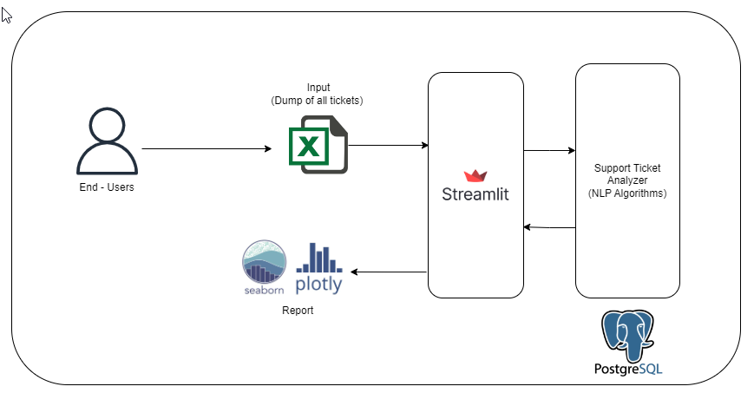

|  |  |  |  |
| --- | --- | --- | --- |
| # | Component | Technology | Purpose |
| 1 | Support Ticket Analyzer | Natural Language Processing | * View ticket based on the category/support group/service along with the count of the ticket in each month. * List of ticket with no category * Count of tickets in each status and priority. * Assign the ticket to the appropriate user. (this requirement can be de-scoped) * Average time to resolve the ticket. (this requirement can be de-scoped) |
| 2 | Streamlit | GUI Framework | To get user inputs (excel) and display report using seaborn/ploty |

## Pre-Requisites:

Below are the key pre-requisites.

|  |  |  |
| --- | --- | --- |
| # | Project Phase | Pre-requisites |
| 1 | Project Kick Off | 1. Purchase order 2. Single point of contact (SPOC) for timely clarifications 3. Any existing documentation related to the relevant processes / applications to be made available |
| 2 | Study & Design | 1. Clarification on need basis 2. Sample tickets for each category. (at least 200) 3. List of categories |
| 3 | Development and Unit Testing | 1. Open-source software compliance checks to be done. 2. Excel files with dump of support tickets to be shared with BGSW team by SMT team |
| 4 | UAT | 1. Availability of Key users |
| 5 | Go-Live & Stabilization | 1. Infrastructure to be enabled in the Production Environment. |

## Bill of Materials (BOM)/ Licenses

|  |  |  |  |  |  |
| --- | --- | --- | --- | --- | --- |
| Sl No | Hardware / Infrastructure | Environment | No.s | Unit Price (USD) | Specifications |
| 1 | Linux server | Production, Development | 2 |  | 32 Gb RAM,  250 Gb Disk Space |
| 2 | Postgres | Production, Development | 2 |  | opensource |
| 3 | Streamlit | Production, Development | 2 |  | opensource |

## Assumptions:

1. Scope creep will follow the CR process.
2. Acceptance period in UAT and Production for deliverables is 5 calendar days. If no feedback received on deliverables submitted by BGSW within this acceptance period, the deliverable is deemed accepted.
3. BGSW shall not be liable for any production loss or any other damage.

## Deliverables, Receivables and Acceptance Criteria

|  |  |  |  |  |
| --- | --- | --- | --- | --- |
| # | Project Phase | Deliverables by BGSW | Receivables from ELM | Acceptance Criteria |
| 1 | Project Kick Off | * Project plan and schedule with milestones * Team structure | * Purchase Order * Project Level Agreement * Project Team Structure | * Deliverables are in line with the project scope. |
| 2 | Study | * Requirement Specifications Document (RSD) | * Clarifications on need basis * Sign-off on Requirement Specifications Document (RSD) | * Solutioning covers identified requirements. |
| 3 | Design | * High Level Design Document | * Clarifications on need basis | * Solutioning covers identified requirements. |
| 4 | Development and Unit Testing | * NLP based solution will be built to generate the analysis report | * Clarifications on need basis | * Solution should generate analysis as per the data provided by the user during study phase. |
| 5 | UAT | * UAT support and issue resolution | * Signoff on UAT * Clarifications on need basis | * No critical defects |
| 6 | Go-Live & Stabilization | * Deploy Solution in Production * 2 weeks of Support | * Signoff on Go-Live | * No critical defects |
| 7 | Project Closure | * Documentation * Transition to Operations | * Handover confirmation * Signoff on Project closure | * No deviation from the agreed scope |

# Project schedule

The indicative timeline for this project is 10 weeks as depicted below. The Application engineering, Installation & Commissioning until SOP and post go-live activities would be carried out for each level board.

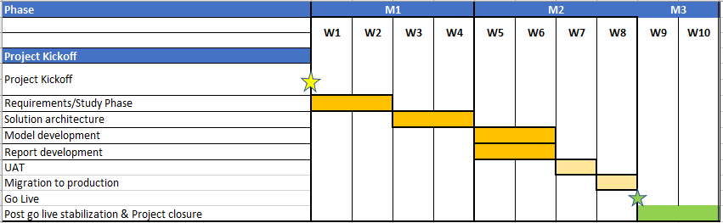

# Project Management

## Change Request Procedure:

The Change Request procedure (shown below) applies to all changes resulting from requirements outside the scope defined in this proposal.

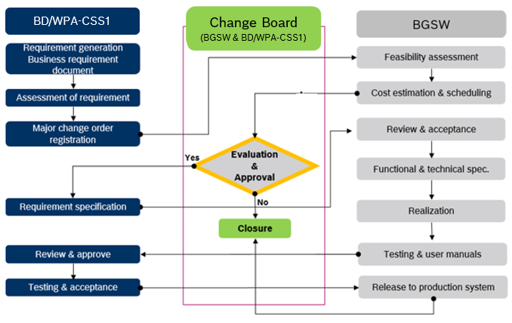

Any activity causing delay in project schedule will have an impact on project commercials and has to be discussed mutually between BGSW and BD/WPA-CSS1. Additional efforts must be incorporated in the project through Change request process.

## Project Execution

Roles and Responsibilities

|  |  |
| --- | --- |
| **BD/WPA-CSS1** | |
| **Role** | **Responsibility** |
| **Manager** | * Responsible for project delivery * Overall project responsibility * Participate in joint reviews with BGSW * Approves change requests |
| **Core Team** | * Responsible for UAT * Reports defects to product owner during UAT |

|  |  |
| --- | --- |
| **BGSW** | |
| **Role** | **Responsibility** |
| **Project Manager** | * Responsible for overall project management * Administrative control of BGSW project team * Project inputs to ETL5 Program Manager * Provide resources for the project * Coordination with teams |
| **Architect** | * Designing solution. * Development of data models for database structures * Integration with source systems * Integration of technical functionalities including scalability, security, reliability |
| **Data Scientist** | * Exploratory Data Analysis (EDA) * Feature Engineering * Model development * Model validation * Model Deployment * UAT support |

## Escalation Management



1. Mandala Sunil Babu (BD/WPA-CSS1)
2. Gokul Ajith (SX/EDS3-MM)
3. Jayabalan Krishna Prasad (BD/WPA-CSS1)
4. Pavan M Laxmeshwar (SX/EDS3-MM)



1. Jois Ramesh K (BD/WPA-CSS1)
2. Shankar Datta M S H (SX/EDS-MM)

**BGSW Development Team**

**1st Level Escalation**

**2nd Level Escalation**

**3rd Level Escalation**

## Communication Plan

An effective communication is necessary for successful execution and tracking of the project. The below communication plan is proposed for the project.

|  |  |  |  |  |
| --- | --- | --- | --- | --- |
| S No | Communication Type / Media | Participants | Frequency | Topics to be discussed |
| 1 | Project status review | BD/WPA-CSS1  BGSW | Weekly | Status of the project |
| 2 | Project team meeting | Project teams | Fortnightly | Activities / status / clarifications on project related activities |
| 3 | Project status reporting | BD/WPA-CSS1  BGSW | Monthly | Monthly status of the project |
| 4 | Issue escalation | BD/WPA-CSS1  BGSW | Ad-Hoc | Issues which are escalated |

## Risks & Mitigations

|  |  |
| --- | --- |
| Risks | Mitigation |
| Unavailability of necessary Infrastructure/Source Systems or the interfaces for extraction of necessary data from the source systems | BD/WPA-CSS1 team to ensure availability of all necessary infrastructure/Source Systems with necessary interfaces for data extraction as defined in the prerequisites |
| Missing clarity of Data field mapping and Calculation for KPIs | BD/WPA-CSS1 team to ensure availability of all Data field mapping and calculations documented and made available to BGSW team before the Design phase |
| Delay in acceptance of deliverables resulting in schedule and effort deviations | BD/WPA-CSS1 should adhere to the plan for review and sign-off. |
| Disturbance due to Natural calamities and social chaos | BD/WPA-CSS1 to have necessary Business Continuity Plan. Schedule to be revisited adjusted, and mutually agreed |

# Commercials

## Price Summary

|  |  |  |  |  |
| --- | --- | --- | --- | --- |
| **Item** | **Topic** | **Duration** | **Total Cost**  **(INR)** | **Remarks** |
| 1 | AI Powered Support Tickets Analyzer | 10 weeks | 5,20,200 |  |

## Payment Milestones

|  |  |  |  |  |
| --- | --- | --- | --- | --- |
| **Item** | **Milestone** | **Timeline** | **Cost in INR per milestone** | **Remarks** |
| 1 | Project kick-off | T+0 | 35% | Advance payment with PO |
| 2 | UAT | T+ 7 weeks | 50% |  |
| 3 | Project Closure | T+10 weeks | 15% |  |

*Note: T indicates project kick-off date*

## Commercial Terms and Conditions

* Taxes as applicable are additional.
* In case the project is stopped for unforeseen circumstances, then invoice will be raised for the effort which has been spent.
* Any delay in the project schedule not attributable to BGSW will lead to a revision in the commercial estimates which will be discussed and agreed upon.
* Any change in scope or schedule from the proposal may involve re-evaluation of the pricing and revision (upward or downward) if required.
* Any change in the assumptions relating to responsibilities will involve Change Order processing and follow up proposal.
* Project start is subject to publishing of names of business users, project manager from BD/WPA-CSS1, sign off on schedule and single point of contact in IT.
* BD/WPA-CSS1 shall bear cost of travel, accommodation, and allowance in case of any travel.
* Any clarifications on the invoice to be completed within 10 days from the date of invoice.
* Invoices are payable without deduction within thirty (30) days from the date of invoice.

# Signatures